Design Notes

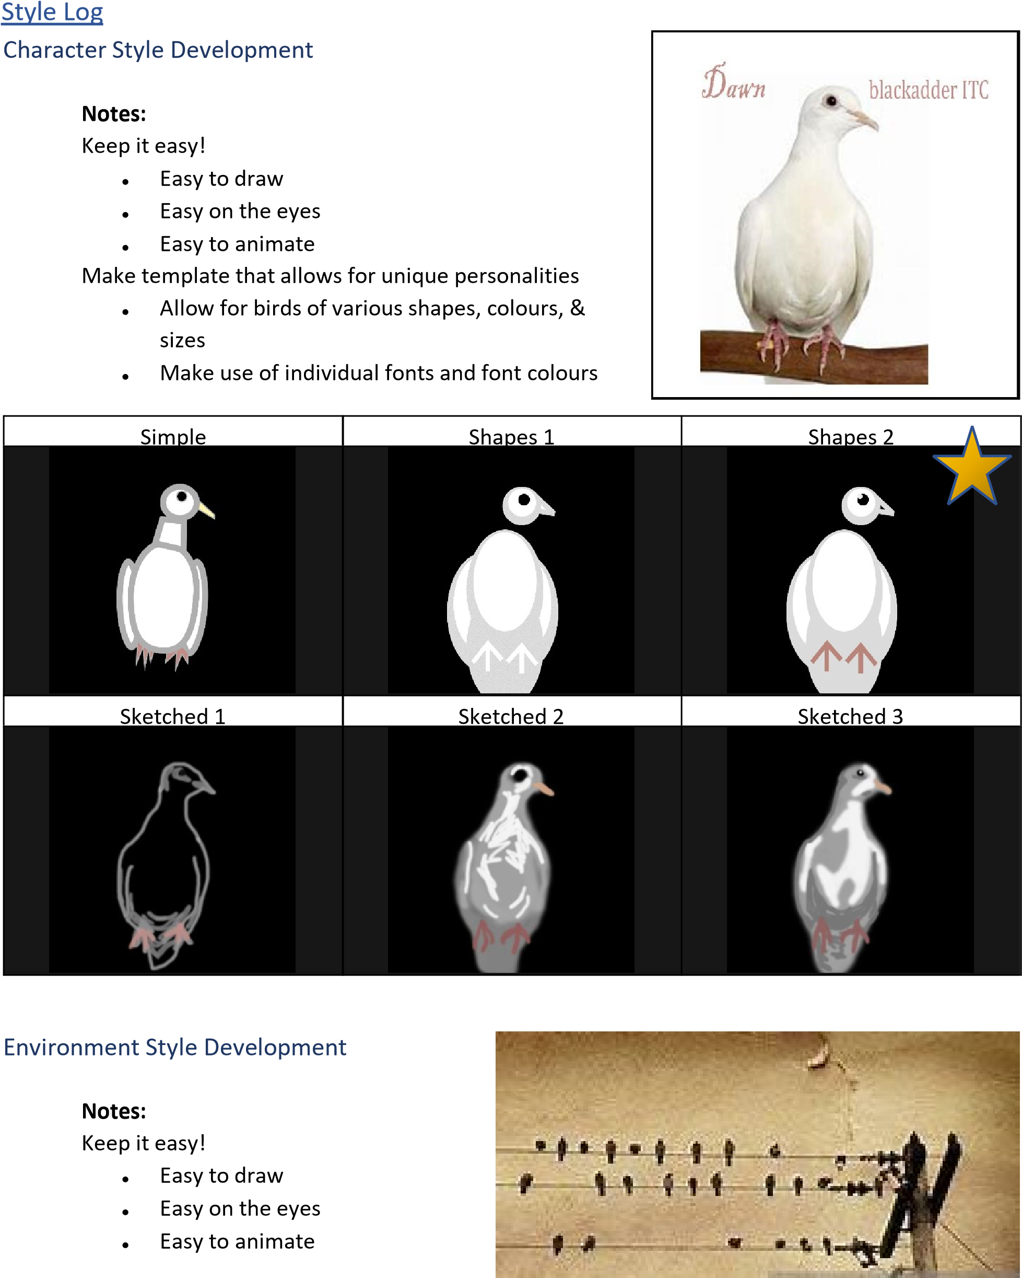

Make sure the birds will fit on wire and that they are visible against the background.

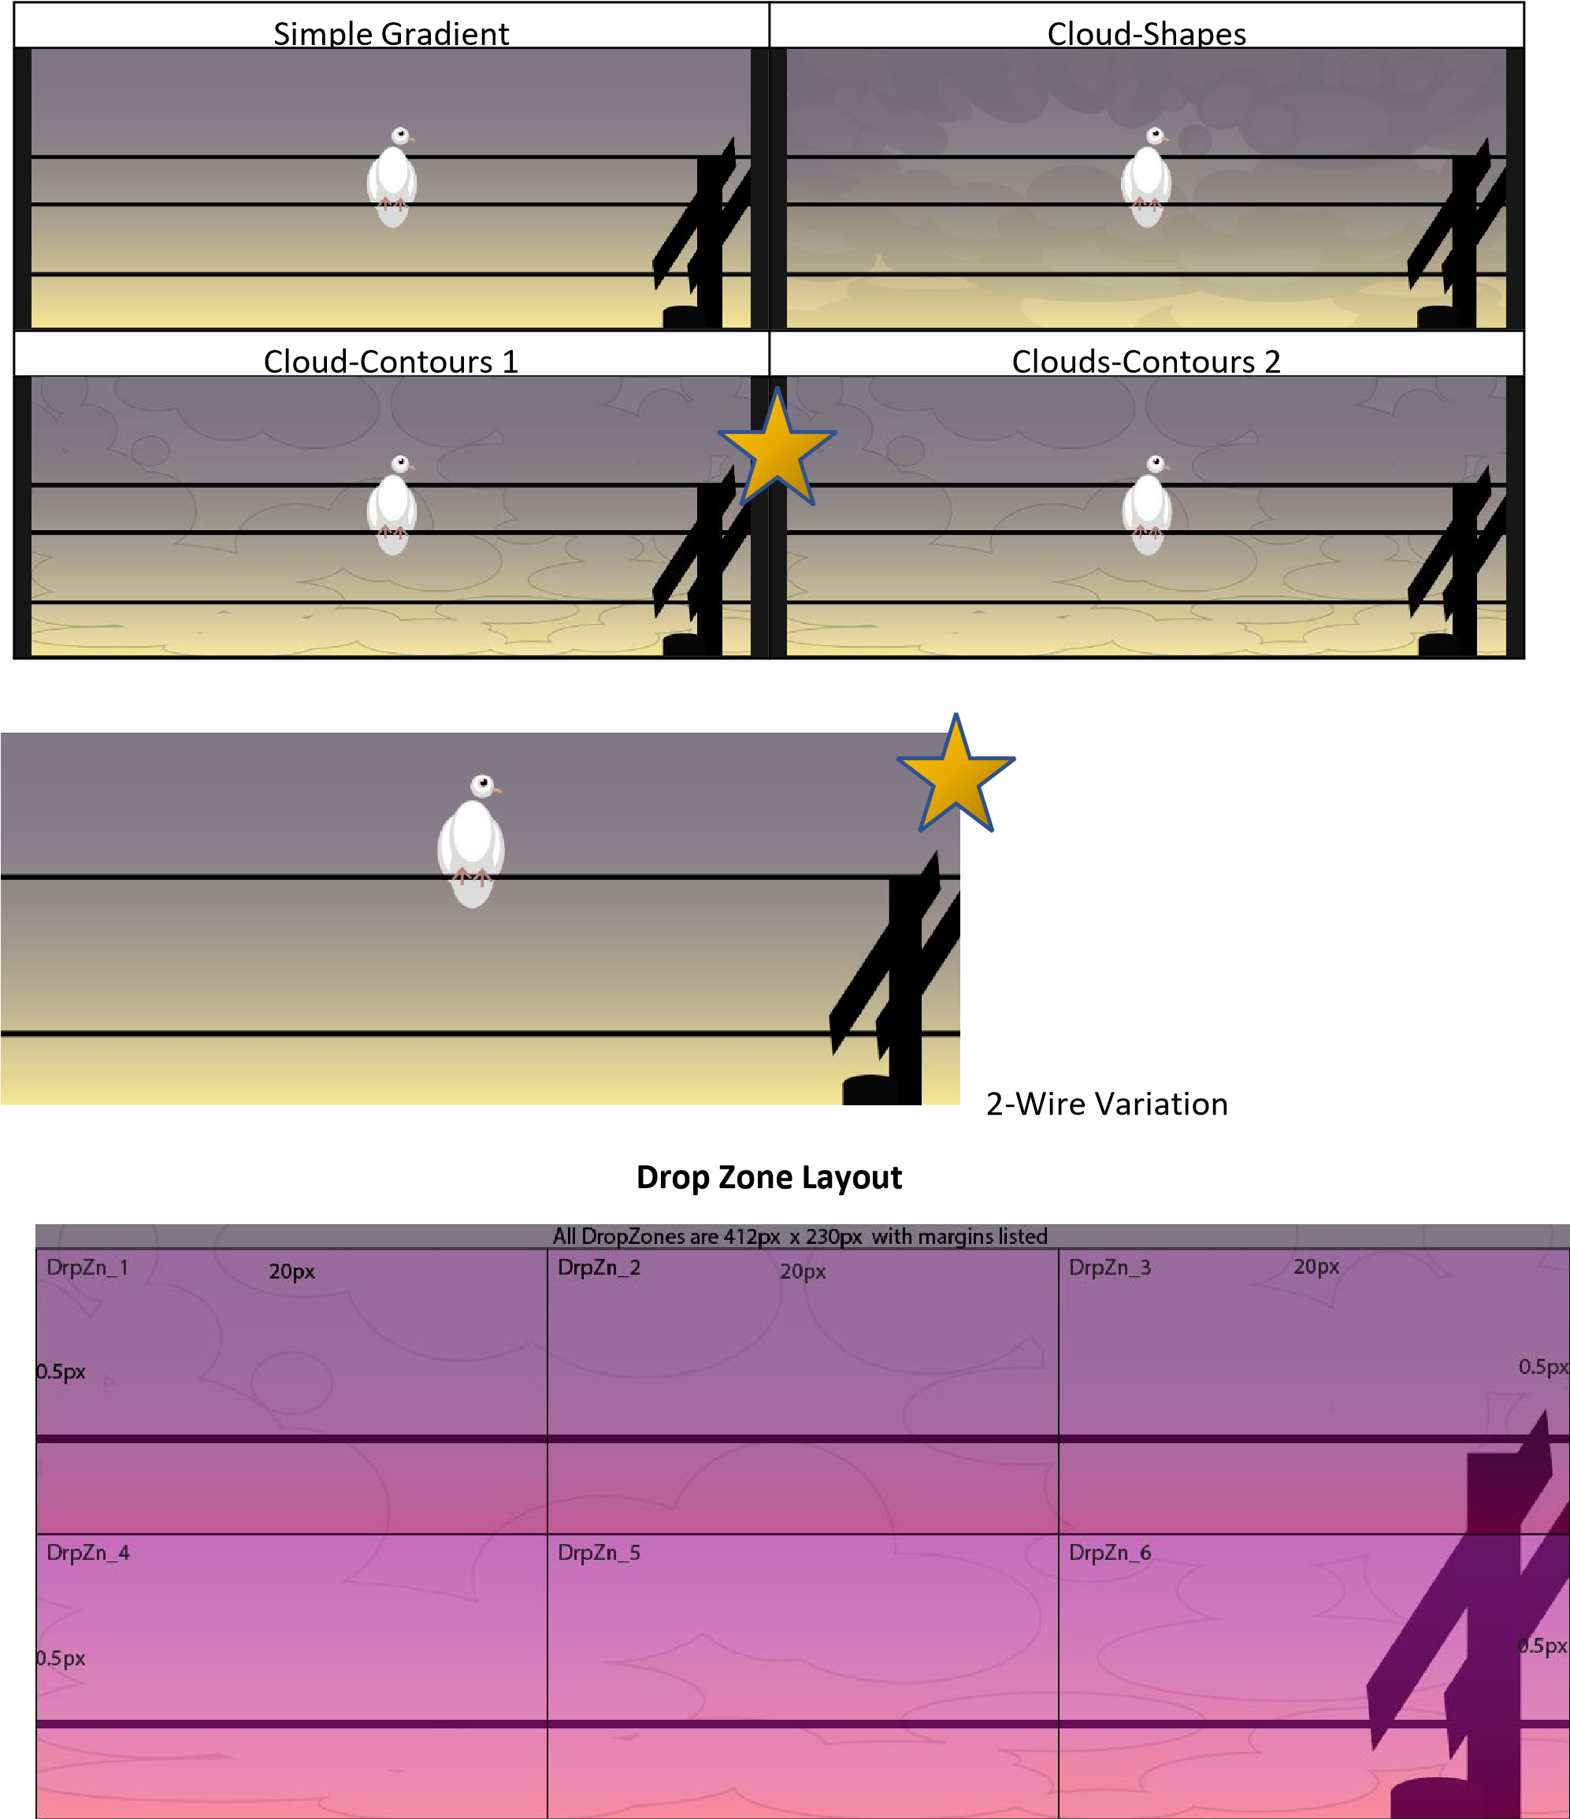

Character Log

Characters

|  |  |  |  |
| --- | --- | --- | --- |
|  |  |  |  |
|  |  |  |  |
|  |  |  |  |

Character Guide

|  |  |  |  |  |
| --- | --- | --- | --- | --- |
| **Name** | **Font** | **Colour**  **Class** | | **Sound** |
| **Billy** | Magneto Bold | 096FC1 | Synth | billy.wav |
| **Clint** |  |  | Melody | clint.wav |
| **Dawn** | Blackadder ITC | DBDBDB | Melody | dawn.wav |
| **Haley** |  |  | Drums | haley.wav |
| **Hank** | Franklin Gothic Heavy | A58958 | Drums | hank.wav |
| **Hillary** |  |  | Bass | hillary.wav |
| **Jay** |  |  | Drums | jay.wav |
| **Jessica** |  |  | Synth | jessica.wav |
| **Paige** | Berlin Sans FB Demi Bold | 9B9EA4 | bass | paige.wav |
| **Patrick** | Bookman Old Style | D6DB7F | Melody | patrick.wav |
| **Shawn** |  |  | Bass | shawn.wav |
| **Tracy** | Freestyle Script | D6C322 | Synth | tracy.wav |

Icons Background Colour

drums: #f6e58d

melody: #55efc4

synth: #34ace0

Bass: #fd79a8